**Export Test**

**Instruction Manual**

Version 2.0 Written 09.01.2013

**Overview**

The purpose of the files in the Export Test folder is to extract, organize and filter test data from DIAdem Database for different analysis.

Two steps are required to complete this task. First one needs a test report filled out by test engineers as input. Using the Excel sheet “Export Test”, a configuration file is created.

Input Configuaration File

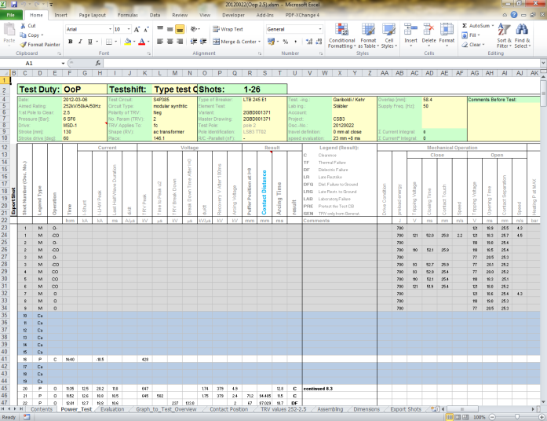 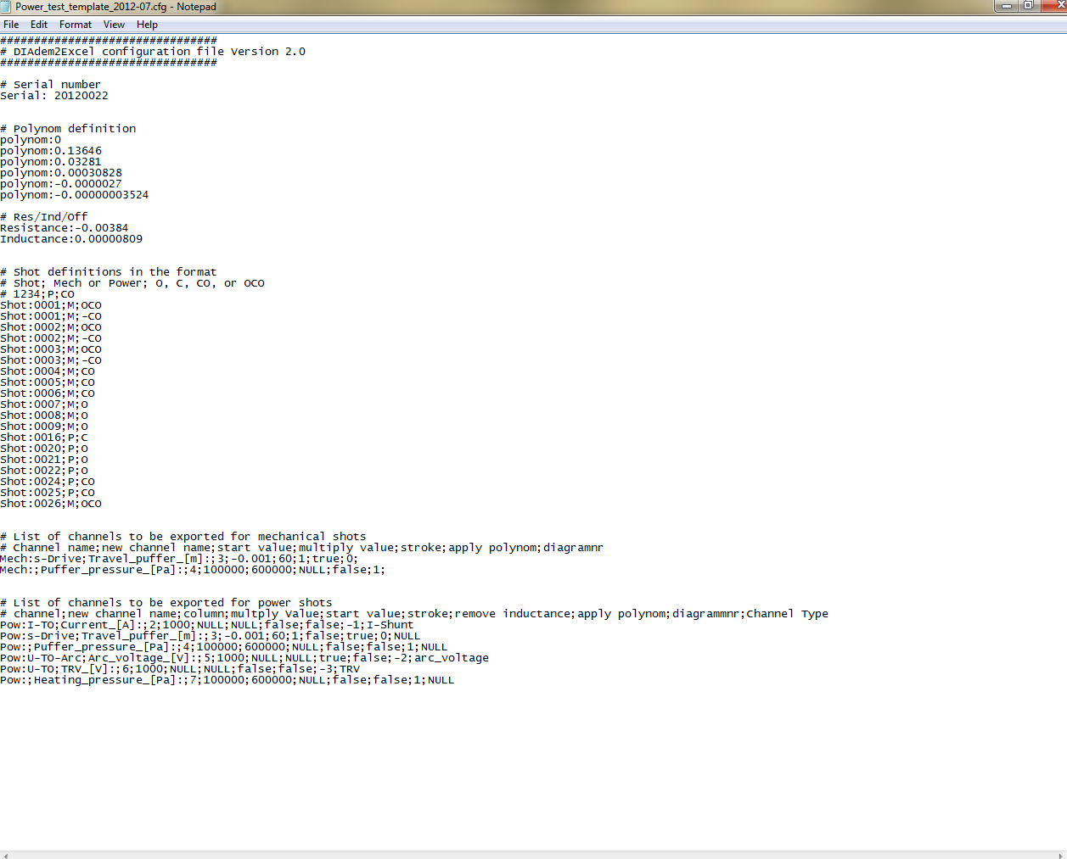

Second the configuration file is used as input to DIAdem and three separate folders (Excel, PDF, and SDF) are created. These folders contain the filtered and organized the data.

Configuration File Input Output Folders

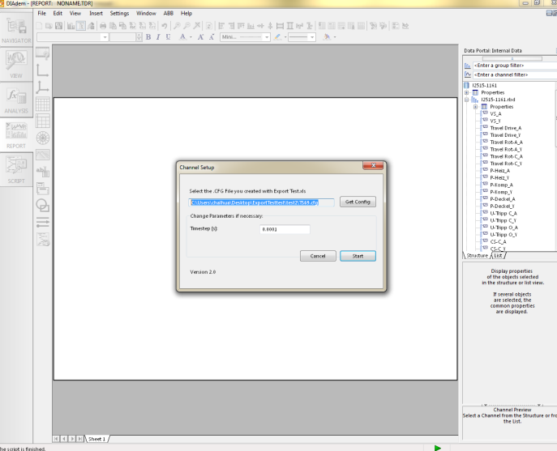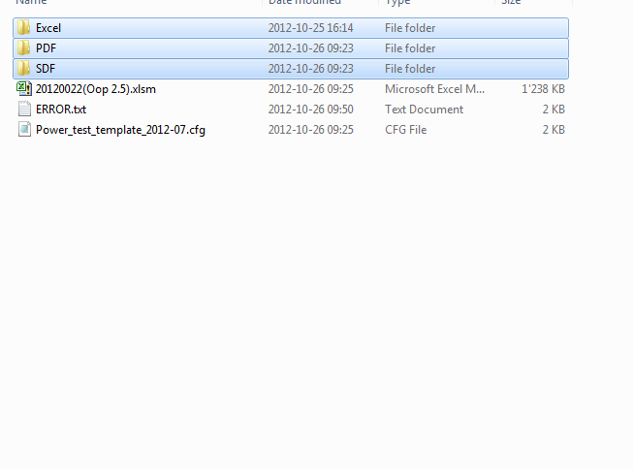

Several modifications of the data will be made by the script during the export process:

* Remove unnecessary data before and after the shot.
* Make all channels equidistant.
* Apply multiplication factors and offset values.
* Convert the travel curve from degrees to meters according to a specified travel Polynomial.
* Smooth the travel curve.
* Remove the influence of stray inductance and resistance on the signals.

**Instructions**

Before you start with the export procedure please make sure that you own the newest version of the scripts. These are updated automatically when you run DIAdem by the batch file DIAdem.bat. Also make sure the excel test report is also up to date, if not the important data must be copied to a new excel test report.

Start with the Excel sheet Export Test vxx.xls which is located in the folder “\DIAdem\abbext\ExportTest”:

1. Open the worksheet “Export Test” and copy it to the test report of the test shift which you want to export. Make sure that no sheet with the name “Export Test” already exists in the test report.



1. Open the worksheet “Power_Test” in the test report with all shots of the test shift. (if it is an old version of the test report, see appendix for how to transfer data to the new sheet) Then select all shots you wish to export by typing “x” into the particular rows of the column “Export Shot”. If this column does not exist, create a new column at an arbitrary position and label it “Export Shot”.

For O-CO shots, select both the O and CO part.

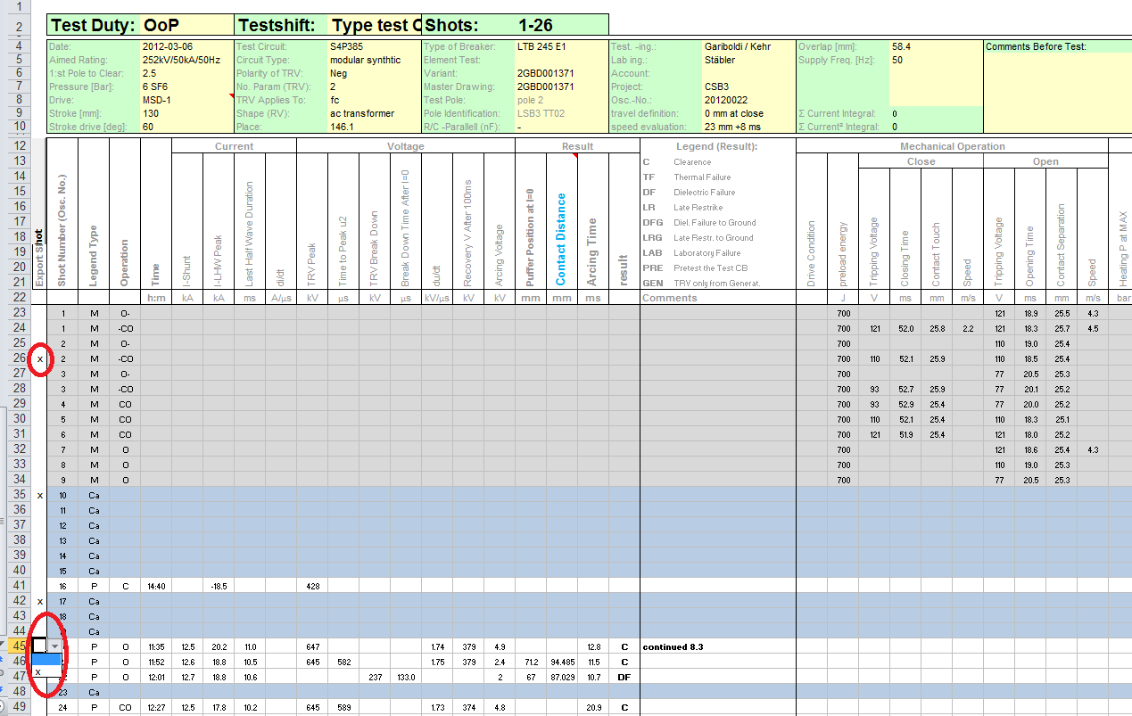

1. Now go to DIAdem and load one shot (power shot, if available) from DIAdem by selecting “ABB” tab then “Load Tests”, enter the oscillation number found at the top of the power_test sheet in excel and “/” and the shot number. For example “20120022/16”. Click load.

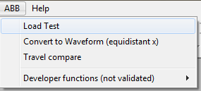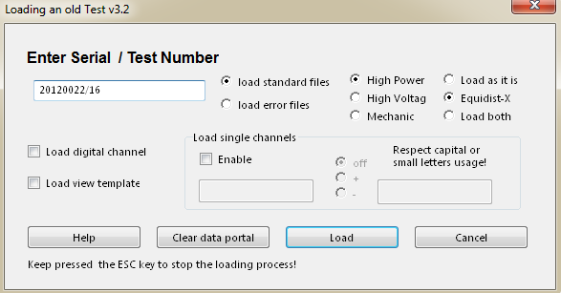

Then one should see many channels on the right. Find the desired channels and fill in the names in the excel export sheet. Leave the “Channel Name” column empty if the channel is not desired. Make sure the names match exactly. If more channels are needed to be exported in addition to the ones already in the green box, add them to the lines below.

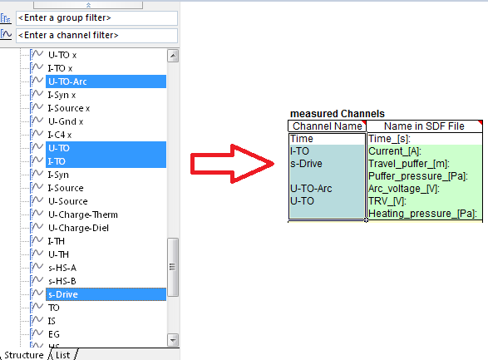

1. Also fill in the yellow boxes in the “Start Value” Column, see the comments in the box as to where to find them.
2. If the measurement data for the travel curve are already in distance, select “TRUE” for the Travel curve. If the measurement data are in angle, select “‘travel – polynom’”. The green boxes should not be changed unless one has good knowledge regarding how DIAdem script function. The end result of the “measured Channels” box should resemble this.

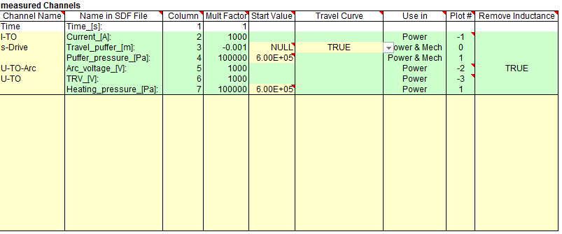

1. (Skip this step if arc voltage is not desired) To export the correct arc voltage, one must filter out the influence of the intrinsic influence of the circuit breaker. To do so, go the DIAdem with a power shot already loaded. Go to “View” tab on the left and draw in the arc voltage and current channel. Select “n Systems” on top to see the two curves in different Y-axis.

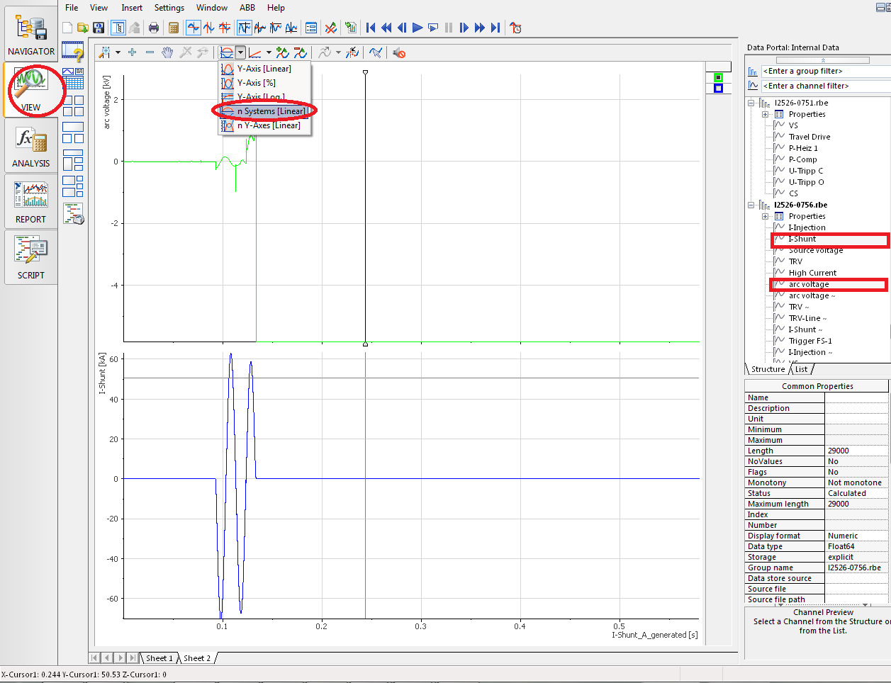

Now zoom into the beginning part of the arc voltage that most resembles a sine wave. Select this interesting part by right click and dragging. From this part the inductance and resistance of the circuit breaker can be calculated. Using the tools indicated on the picture below, measure the peak value of the voltage, current (if asymmetrical, use peak to peak value divide by two) and the time difference between the two (defined as voltage peak time minus current peak time).

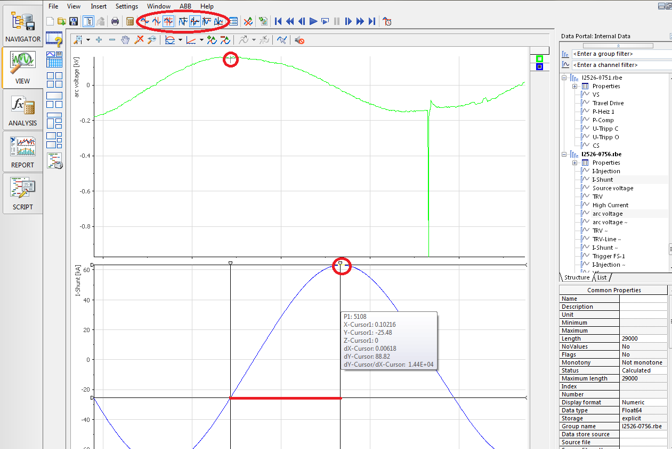

Now enter these values into the excel export test sheet. It should automatically calculate the resistance and inductance value.

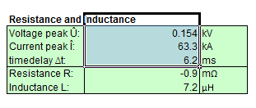

1. Click on “Write Configuration File” and the first part is complete.

Once the configuration file has been made, the second part can be started.

1. Click on the “ABB” tab and then “developer functions” and select “Export Test”.

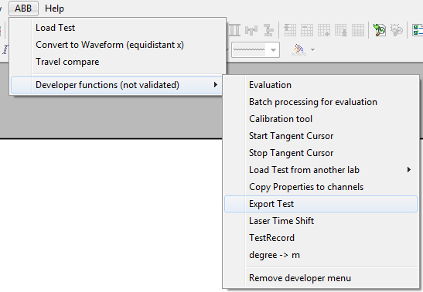

1. Click on “Get Config” and specify the configuration generated with Excel from part one. Select appropriate time step and click start.

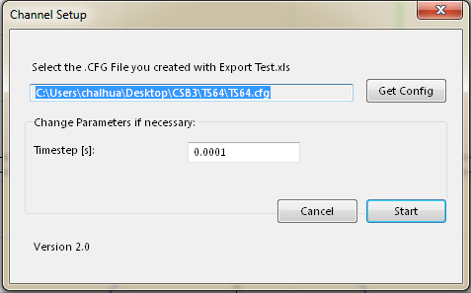

1. If at least one of the shots to be exported, a filtering window will come up. The inductance and resistance value in the boxes are calculated in the first part.

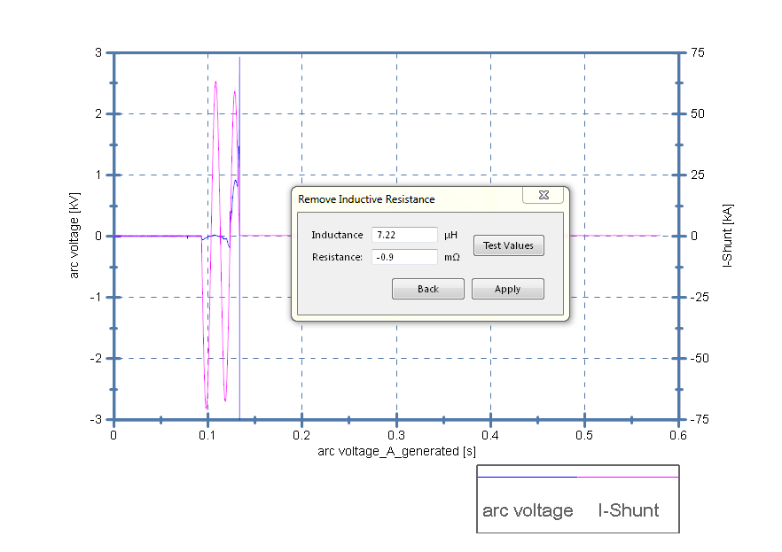

If the result does not appear satisfactory, one can alter these values to find a better set of values. First change the inductance to make the beginning sine wave part of the arc voltage in phase with the current. Then change the resistance to flatten the curve (see below example). Click “Apply” to proceed to the next step.

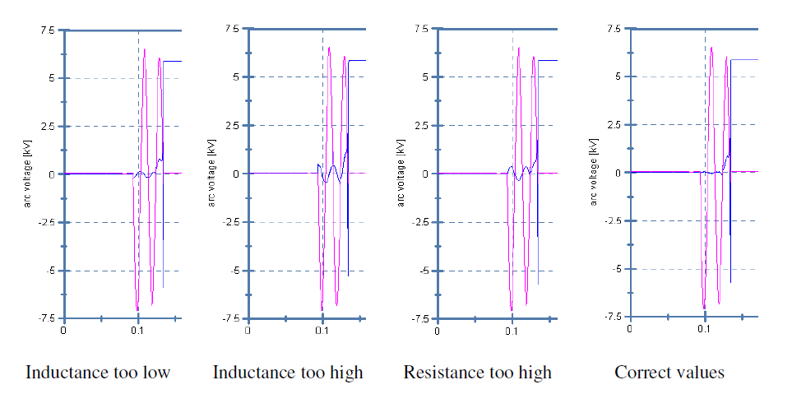

1. If travel curves are selected to be exported, for every shot, a window will appear which allows the user to smooth the travel curve. It consists of two parts, first “remove spike” part removes large spikes from the curve; second, the “Smooth Travel Curve with Moving Average” part smooth out small oscillations. See example below. Test these values until one is satisfied. Be aware that in the smooth curve part, a large number can alter the data significantly, and should be avoided.

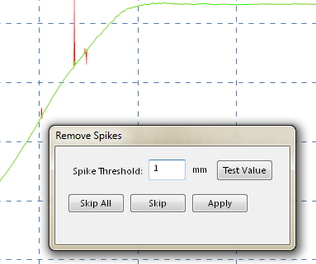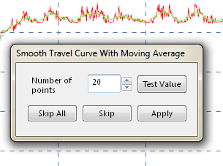

1. Continue until every shot is done. This can take some time depending on the number of shots.

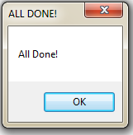

1. Check the PDF file to see whether all shots are exported according the expectation.

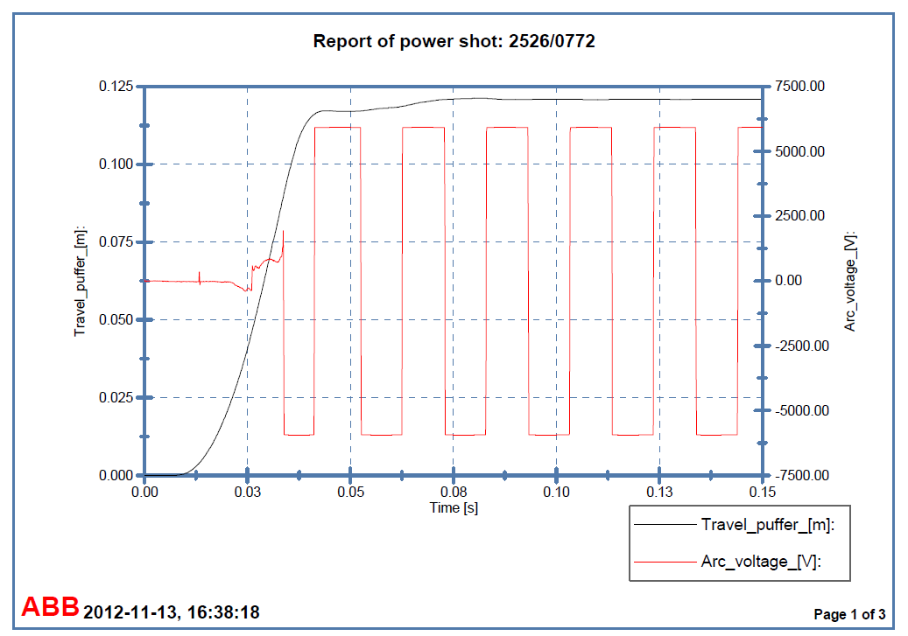

**Common Problems**

Below are some of the common problems as well as possible solutions.

Problem: Some channels are missing in the output files and messages like this are appearing in the “Error.txt”: “Error in Shot: l2526-1289.rbd Couldn't find channel: Travel Drive”

Solution: The DIAdem script was not able to load specific channels. Please load a shot of the test series in DIAdem and check the spelling of the channel names in the Excel sheet.

Problem: An error message appears in DIAdem “The index … does not match any of the elements in the list.”

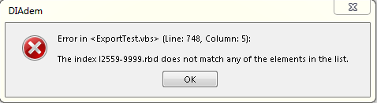

Solution: The script could not load a specific shot because it was not able to find it on the server. Make sure that all shots you want to export exist on the DIAdem server “acqui”.

Problem: The DIAdem script quits without exporting any files but also without displaying an error message.

Solution: Check the format of the channel names in DIAdem. Load a shot directly from the Navigator in DIAdem, not by using the function “Load Shot” in the ABB menu. The time channels must always have a name like “Name_A”, “Name_AB” or “Name_ABA”, the Y channels like “Name_Y”. Otherwise the script cannot find the channels, so the channels have to be renamed first. Maybe ask Marco Mailand for assistance in this case.

**Appendix**

**Transfer Data from Old Version of Test Report**

1. Open both the old test report and a blank new test report, copy the “Shot Number”, “Legend Type” and “Operation” data to the same location new test report.

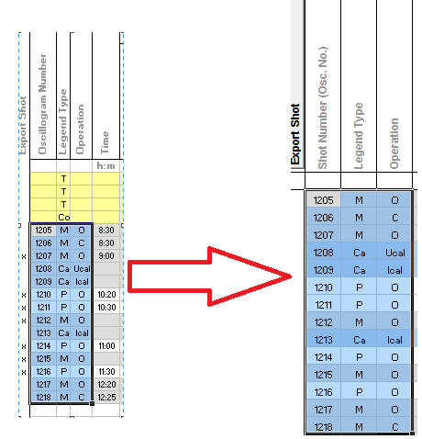

2. Copy over the values of “pressure”, “stroke”, “stroke drive” and “osc.-No.” to the new template.

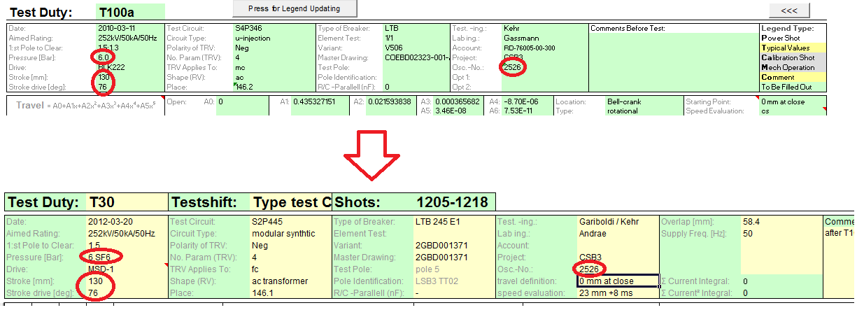

3. If the travel is measured in degrees, also copy the travel polynomial coefficient to the new template. One can also enter the total travel in the calculation box to confirm the travel in mm is correct.

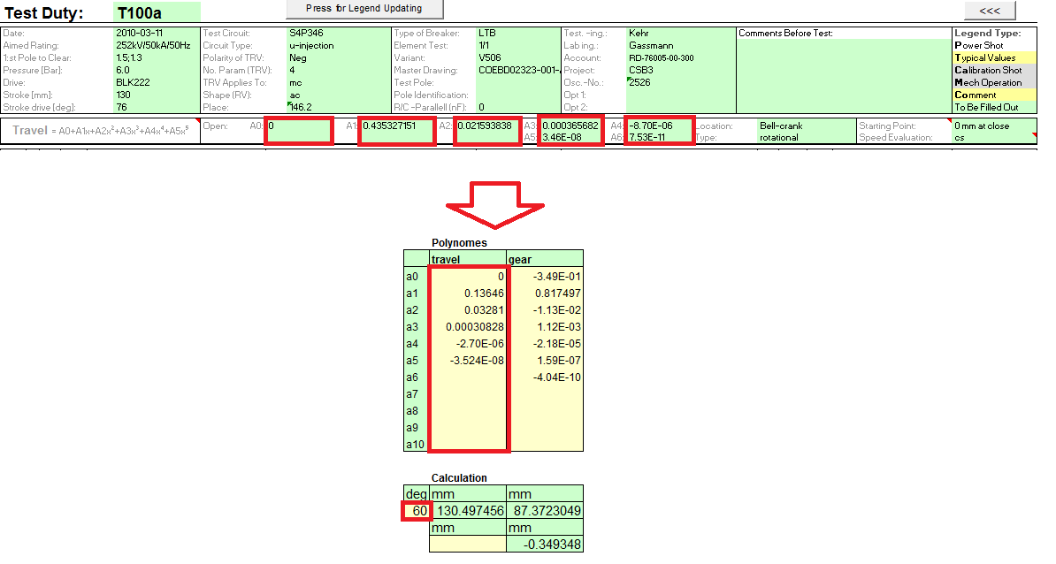

Continue back to Step 2 when this is complete.